Diffusion and Osmosis

- What is diffusion?
__________________________________________________________________________________________________________________

- The image below shows several particles in a container on the left.

- In the container on the left, identify a region of high concentration.
- In the container on the left, identify a region of low concentration.
- After diffusion has occurred, draw a quick illustration of equilibrium in the container on the right.

- Explain what semipermeable means.
__________________________________________________________________________________________________________________

- Three cells (which have been magnified) are placed in separate beakers. Their salt concentrations are written as percentages. The surrounding fluid’s salt concentration is also written as a percentage.

Beaker A Beaker B Beaker C

19% 14% 38%
5% 22% 38%

- For each beaker, state whether water will move inside the cell, outside the cell, or not at all.
- In Beaker A, water will move ______________
- In Beaker B, water will move ______________
- In Beaker C, water will move ______________

- Does this situation involve osmosis or diffusion? Explain your answer.
______________________________________________________________________________________________________________
- The image below on the left shows healthy red blood cells. A biologist extracted some red blood cells and placed them in a fluid. After some time, the cells became shrivelled up, as shown in the image on the right.

What conclusion can you draw about the fluid that the cells have been placed in?
________________________________________________________________________________________________________

- Remember the potato lab you did earlier in the year? In that lab, you carved three small wells in a potato (which has a very small natural salt concentration). In one well, you inserted salt crystals. In another, you inserted pure water. In the third, you inserted a dilute saltwater solution.
Pure water

Dilute saltwater
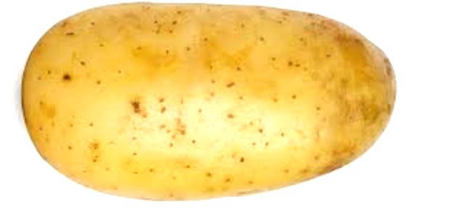
Salt crystals

A B C

Use your knowledge of osmosis to describe what you expect to see in each well:
- Well A ____________________________________________
- Well B ____________________________________________
- Well C ____________________________________________

- A goldfish is a freshwater fish that is commonly kept as a pet. Suppose that you and your pet goldfish decide to visit the ocean during your summer vacation. After thinking about it, you wonder if your goldfish would be happier in the ocean. After an emotional goodbye, you decide to set your goldfish free and watch it swim off into the ocean. Use your knowledge of osmosis to explain why this is a bad idea.
______________________________________________________________________________________________________________________________________________________________________________

