Cells worksheet
- Name three components that animal cells have in common with plant cells.
- _______________________________________
- _______________________________________
- _______________________________________

- Identify the parts of the cell.
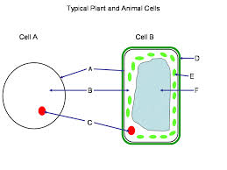
A
B
C
D
E
F

- State the function of the following parts of the cell.
- Cell membrane: _________________________________________________________________
- Nucleus: _______________________________________________________________________
- Cytoplasm: _____________________________________________________________________

- For each of the following characteristics, indicate with a checkmark, which ones relate to an animal cell or a plant cell.
Characteristics | Animal Cell | Plant Cell
Large vacuole
Geometric shape
Absence of chloroplasts
Rounder shape
Cell wall

